Attachments for Encounter Updates

Encounter Quarterly Reports - communication
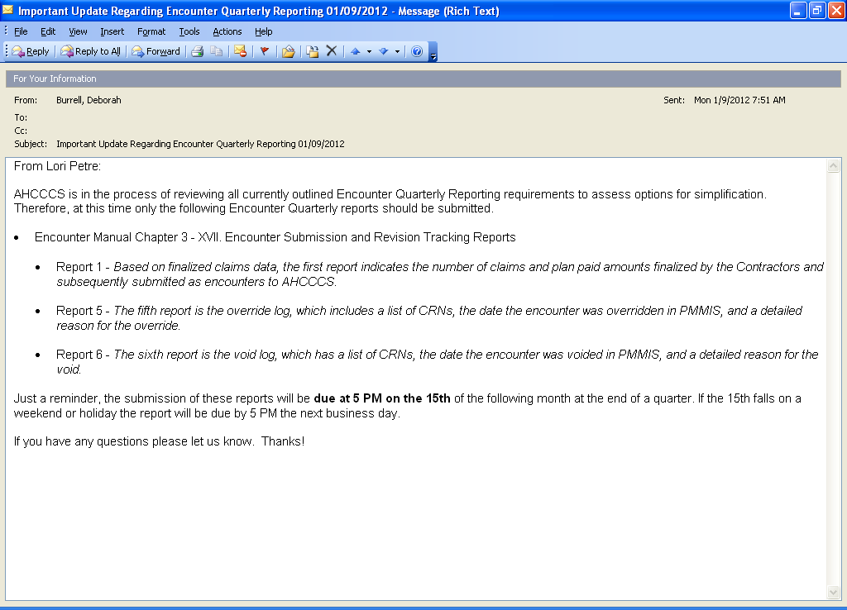

Override request communication email
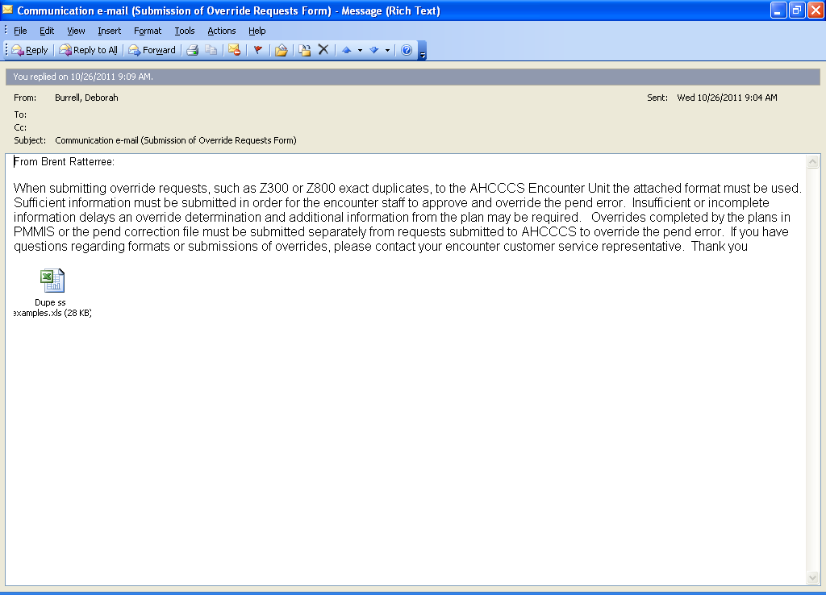

Override spreadsheet examples

 |  |  |  | HCFA/DENTAL/RX Duplicate Spreadsheet for Over-ride
X_RAY AHCCCS CRN pending | Plan Comments* (see below) | Member ID | Service Begin Date | Service End Date | Service code (CPT, HCPCS, NDC) | DX code(s) | All modifiers | Tooth number, surface | Paid Units | Service Provider ID | Provider Type | AHCCCS procedure daily max units (RF113)
00000000000000 | Z300 - per documentation 3 chest x-rays done at three different times | A1111111 | 06/30/08 | 06/30/08 | 71010 |  | 26, 76 |  | 1 | 123456 |  | 5
Adjudicated Encounter
00000000000000 |  | A1111111 | 06/30/08 | 06/30/08 | 71010 |  | 26, 76 |  | 1 | 123456 |  | 5
Transportation AHCCCS CRN pending |  | Member ID | Service Begin Date | Service End Date | Service code (REV code, CPT, HCPCS, NDC) |  | All modifiers | Tooth number, surface | paid units | service provider tax id |  | AHCCCS procedure daily max units
00000000000000 | Two ambulance transports same date/one at 5:40 a.m. & second at 2:35 p.m. Interfacility transport/Banner HomeCare to Univ Phys Hospital & return | A0101010 | 3/25/08 | 3/25/08 | A0425 |  | NH |  | 1 | 123456 |  | 999
Adjudicated Encounter
00000000000000 |  | A0101010 | 3/25/08 | 3/25/08 | A0425 |  | HN |  | 1 | 123456 |  | 999
Dental AHCCCS CRN pending |  | Member ID | Service Begin Date | Service End Date | Service code (REV code, CPT, HCPCS, NDC) |  | All modifiers | Tooth number, surface | paid units | service provider tax id |  | AHCCCS procedure daily max units
 | Code D4341 reviewed and multiple quadrants/services rendered same day, same patient. These are not duplicates and are ok to allow. Marked for adjudication. |  | 4/12/2010 | 4/12/2010 | D4341 |  |  | LR | 1 | 123456 |  | 4
Adjudicated Encounter
 |  |  | 4/12/2010 | 4/12/2010 | D4341 |  |  | LL | 1 | 123456 |  | 4
Back Injections AHCCCS CRN pending |  | Member ID | Service Begin Date | Service End Date | Service code (REV code, CPT, HCPCS, NDC) |  | All modifiers | Tooth number, surface | paid units | service provider tax id |  | AHCCCS procedure daily max units
10101010101010 |  |  | 10/4/2010 | 10/4/2010 | 64493 |  | 50 |  |  | 123456 |  | 1
Adjudicated Encounter
01010101010101 |  |  | 10/4/2010 | 10/4/2010 | 64493 |  | 50 |  |  | 123456 |  | 1
*Note: If transportation, list times for each transport. For back injections, plan needs to list injection sites; example L1, L2, C1, C2, and so forth.

 |  |  |  |  | Dupe UB Override Log
AHCCCS CRN pending | Plan Comments | Recipients ID | Service Begin Date | Service End Date | Service Code (HCPCS, CPT) | (REV code, NDC) | All modifiers | paid units | service provider id | Provider specialty | AHCCCS procedure daily max units (RF127) | G0 condition code* (see note below)
000000000002 | Not a duplicate. Pending claim for IP admit and duplicating claim is for ER visit. | A00000000 | 05/29/2010 | 06/02/2010 |  | 206, 250, 255, 258, 271, 301, 305, 324, 341, 343, 351, 352, 424, 450, 460, 482, 483, 730, 921 |  | 1 | 123456789 | 02 |  | This scenario, G0 would be used.
Adjudicated Encounter
000000000000 |  | A00000000 | 05/29/2010 | 05/29/2010 |  | 301,305,324,450, 730, |  | 1 | 123456789 | 02
AHCCCS CRN pending | Plan Comments | Recipients ID | Service Begin Date | Service End Date | Service Code (HCPCS, CPT) | (REV code, NDC) | All modifiers | paid units | service provider id | Provider specialty | AHCCCS procedure daily max units | **G0 condition code
000000000002 | Not a duplicate. Pending claim for IP admit and duplicating claim is for OP visit. | A00000000 | 08/10/2010 | 08/12/2010 |  | 112, 250, 258, 272, 302, 305, 721, 722 |  | 2 | 123456789 | 02 |  | This scenario, G0 would be used.
Adjudicated Encounter
000000000000 |  | A00000000 | 08/10/2010 | 08/10/2010 |  | 250,761 |  | 1 | 123456789 | 02
AHCCCS CRN pending | Plan Comments | Recipients ID | Service Begin Date | Service End Date | Service Code (HCPCS, CPT) | (REV code, NDC) | All modifiers | paid units | service provider id | Provider specialty | AHCCCS procedure daily max units (RF127) | G0 condition code* (see note below)
000000000002 | Pending encounter with Dr K admit 7PM at Mercy Gilbert for Urgent Care. Accepted encounter with Dr Butler admit 8PM at Mercy Gilbert for ER services | A00000000 | 1/18/2009 | 1/18/2009 |  | 250, 271, 272, 324, 456 |  | 2 | 123456789 | 02
Adjudicated Encounter
000000000000 |  | A00000000 | 1/18/2009 | 1/19/2009 |  | 250, 300, 302, 305, 306, 410, 450, 636 |  | 1 | 123456789 | 02 |  | This scenario, G0 would be used.
AHCCCS CRN pending | Plan Comments | Recipients ID | Service Begin Date | Service End Date | Service Code (HCPCS, CPT) | (REV code, NDC) | All modifiers | paid units | service provider id | Provider specialty | AHCCCS procedure daily max units | **G0 condition code
000000000002 | Not a duplicate. Outpatient claim duplicating off Inpatient admit. Same facility | A00000000 | 09/14/2010 | 09/14/2010 |  | 301, 302, 305, 307, 762, 920 |  | 2 | 123456789 | 02 |  | This scenario, G0 would be used.
Adjudicated Encounter
000000000000 |  | A00000000 | 09/14/2010 | 09/17/2010 |  | 122, 250, 270, 272, 301, 302, 305, 360, 942 |  | 1 | 123456789 | 02
* Note: Report G0 condition code when multiple medical visits occurred on the same day in the same revenue center but the visits were distinct and constituted independent visits.

