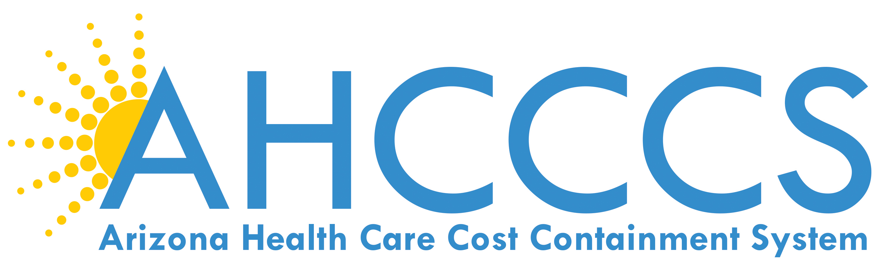

September 21, 2016

9:30 AM – 12:30 PM

701 E. Jefferson St, 3rd Floor

Phoenix, Arizona

Call in: 1-877-820-7831

Passcode: 988847

 | TOPIC | PRESENTER
9:30 am | AHCCCS Update | Tom Betlach
10:00 am | Driving Members to Valued Providers | Health Choice Arizona
10:15 am | CMO Update | Dr. Sara Salek
10:45 am | Quality Update | Jakenna Lebsock
11:00 am | Meeting Adjourned
Next AHCCCS Contractor Update Meeting :
November 16, 2016

