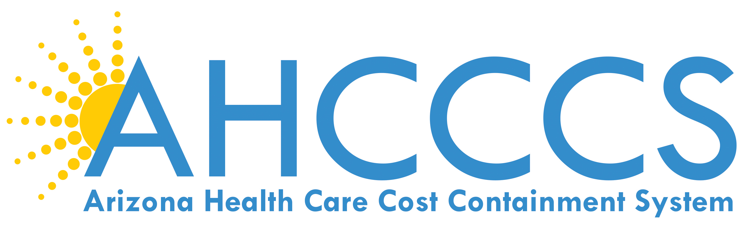

May 17, 2017

9:30 AM – 12:30 PM

701 E. Jefferson St, 3rd Floor

Phoenix, Arizona

Call in: 1-877-820-7831

Passcode: 988847

 | TOPIC | PRESENTER
9:30 am | AHCCCS Update | Beth Kohler
10:00 am | Rates/Reimbursement Update | Shelli Silver
10:20 am | Targeted Investment Update | Shelli Silver
10:25 am** | Opioid Update | Shana Malone
10:55 am** | ASD Advisory Committee Update | Dr. Sara Salek
11:00 am | Website/Social Media Update | Heidi Capriotti
11:10 am | New Deliverable SharePoint Overview | Christina Quast
11:30 am | Meeting Adjourned
Next AHCCCS Contractor Update Meeting :
July 12, 2017
9:30 AM – 12:30 PM

**These topics were not presented on at the May 17th meeting, and will be scheduled for presentation at the next AHCCCS Update Meeting.

