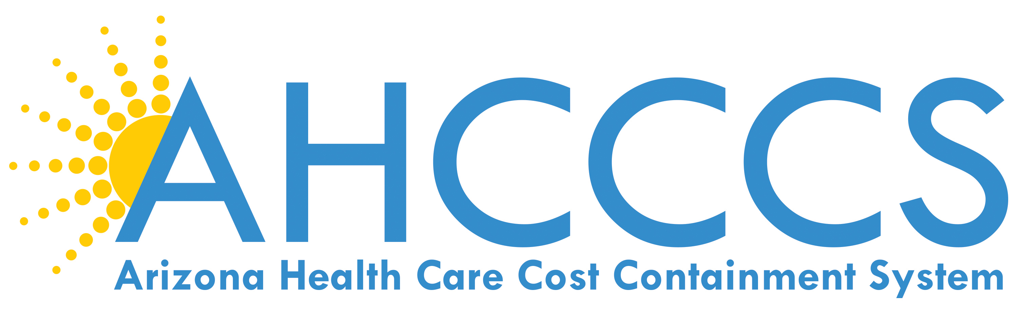

July 12, 2017

9:30 AM – 12:30 PM

701 E. Jefferson St, 3rd Floor

Phoenix, Arizona

Call in: 1-877-820-7831

Passcode: 272084

 | TOPIC | PRESENTER
9:30 am | AHCCCS Update | Tom Betlach
10:00 am | Rates Update  IMD Update | Shelli Silver
10:15 am | E-prescribe Results | Cynthia Layne
10:25 am | Opioid Update | Shana Malone
10:55 am | ASD Advisory Committee Update | Dr. Sara Salek
11:00 am | MCO Scorecard Update | Jamie Robin
11:10 am | End of Life | Melissa Arzabal
11:30 am | Meeting Adjourned
Next AHCCCS Contractor Update Meeting :
September 20, 2017
9:30 AM – 12:30 PM

