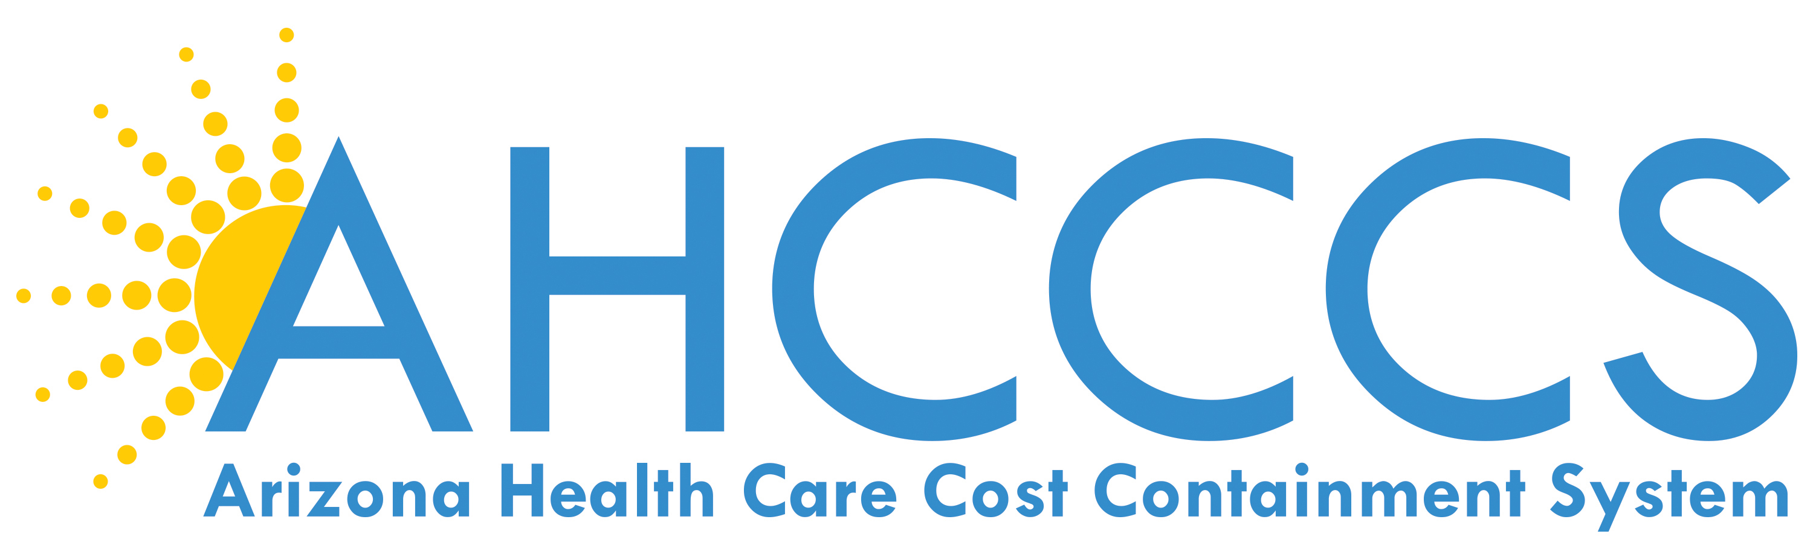

January 25, 2017

9:00 AM – 11:00 AM

701 E. Jefferson St, 3rd Floor

Phoenix, Arizona

Call in: 1-877-820-7831

Passcode: 988847

 | TOPIC | PRESENTER
9:00 am | AHCCCS Update  Waiver Update | Tom Betlach  Beth Kohler
9:30 am | Rates Update | Shelli Silver
9:45 am | 2018 RFI | Shelli Silver
10:20 am | Opioid Update | Dr. Sara Salek
10:40 am | Provider Survey Results | Christina Quast
11:00 am | Meeting Adjourned
Next AHCCCS Contractor Update Meeting :
March 15, 2017
9:30 AM – 12:30 PM

