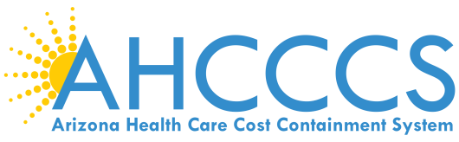 | AGENDA  STATEWIDE HOSPITAL ASSESSMENT WORKGROUP  May 11, 2015  Gold Room, 701 E. Jefferson St., 3rd Floor  10:30 a.m. – 11:30 a.m.  Teleconference: 1-877-820-7831, ID: 710459#
Scope/Purpose: Planning and implementation of the statewide hospital assessment in conjunction with Medicaid eligibility changes.
Welcome/Introduction |  | Beth Kohler
Enrollment Update |  | Beth Kohler
Total Projected Coverage Payment Update |  | Amy Upston
SFY 2016 Assessment & Timeline |  | Beth Kohler

